T

CANDIDATE
NAME
CIVICS  GROUP |  |  | /

CHEMISTRY 8872/02
Paper 2 17th September 2010
2 hours
Candidates answer Section A on the Question Paper.

Additional Materials: Answer Paper
Graph Paper
Data Booklet

READ THESE INSTRUCTIONS FIRST

Write your Civics Group number and candidate name on all the work you hand in.
Write in dark blue or black pen.
You may use a soft pencil for any diagrams, graphs or rough working.
Do not use staples, paper clips, highlighters, glue or correction fluid.

Section A
Answer all questions.
For Examiner’s Use
Paper 1 |  |  | /30
Paper 2 | A1 |  | /7
 | A2 |  | /12
 | A3 |  | /12
 | A4 |  | /9
 | B |  | /20
 | B |  | /20
Total |  |  | /110

Section B
Answer two questions on separate answer paper.

At the end of the examination, fasten all your work securely together.
The number of marks is given in brackets [ ] at the end of each question or part question.


TEMASEK JUNIOR COLLEGE
Preliminary Examinations
Higher 1

This document consists of 16 printed pages.
Section A

Answer all questions in this section in the spaces provided.

1 |  | A sample of solid iron(II) ethanedioate, FeC₂O₄ was dissolved in 20 cm³ of 1.0 mol dm⁻³ H₂SO₄. The solution was transferred to a 250 cm³ standard flask and made up to the mark with deionised water. 25.0 cm³ of this solution was pipetted and titrated against acidified aqueous potassium manganate(VII). It was found that 25.40 cm³ of 0.0500 mol dm⁻³ solution of potassium manganate(VII) was required for complete reaction.  In this reaction, the manganate(VII) ions undergo the following change:  MnO₄⁻(aq) + 8H⁺(aq) + 5e⁻ → Mn²⁺(aq) + 4H₂O(l)
 |  | (a) |  | Both Fe²⁺ and C₂O₄²⁻ are oxidised by MnO₄⁻ in the above reaction. The half-equation for the oxidation of Fe²⁺ is given below.  Fe²⁺(aq) → Fe³⁺(aq) + e⁻  Write a half-equation to show the oxidation of C₂O₄²⁻ to CO₂.
 |  |  |  | ...................................................................................................................................................
 |  |  |  | ...................................................................................................................................................
 |  |  |  |  |  | [1]
 |  | (b) |  | Hence, write a balanced ionic equation for the reaction between iron(II) ethanedioate and acidified potassium manganate(VII).
 |  |  |  |  |  | [1]
 |  | (c) |  | Calculate the amount of MnO₄⁻ needed for the reaction.
 |  |  |  | [1]
 |  | (d) |  | Hence, calculate the concentration of iron(II) ethanedioate solution in the standard flask.
 |  |  |  | [2]
 |  | (e) |  | Determine the mass of iron(II) ethanedioate in the sample.
 |  |  |  |  |  | [2]
 |  |  |  |  |  | [Total: 7]
 | 2 |  | 0.05 mol of ethyne, C₂H₂, is added to 0.15 mol of O₂ in a reaction vessel. The vessel is immersed in a thermostat at 125ºC, and the volume of gas within the vessel is read continuously. At time A, the mixture is sparked, whereupon the C₂H₂ and O₂ react accordingly to the equation:  C₂H₂ + O₂ → 2CO₂ + H₂O  At time C, 4 g of solid sodium hydroxide is introduced into the vessel. The variation in volume during this time is represented in the following graph.  Time/min  A  B  C  Volume of gas  0 10  D  At constant temperature of 125ºC
 |  |  | (a) |  | (i) |  | Draw a dot-and-cross diagram of ethyne, C₂H₂.
 |  |  |  |  | (ii) |  | State the number of sigma bonds and pi bonds in C₂H₂.
 |  |  |  |  |  |  | ...........................................................................................................................................
 |  |  |  |  |  |  | ...........................................................................................................................................
 |  |  |  |  | (iii) |  | Explain the difference in the formation of sigma bonds and pi bonds, in terms of orbital overlap.
 |  |  |  |  |  |  | ...........................................................................................................................................
 |  |  |  |  |  |  | ...........................................................................................................................................
 |  |  |  |  |  |  | [4]
 |  |  | (b) |  | (i) |  | Define standard enthalpy change of combustion.
 |  |  |  |  |  |  | ...........................................................................................................................................
 |  |  |  |  |  |  | ...........................................................................................................................................
 |  |  |  |  |  |  | ...........................................................................................................................................
 |  |  |  |  | (ii) |  | Using the Data Booklet, calculate the enthalpy change of combustion of C₂H₂.
 |  |  |  |  |  |  | [3]
 |  |  | (c) |  | (i) |  | State the gas or gases remaining in the vessel at the 10 min mark.
 |  |  |  |  |  |  | ...........................................................................................................................................
 |  |  |  |  |  |  | ...........................................................................................................................................
 |  |  |  |  | (ii) |  | Calculate the number of moles of each gas present.
 |  |  |  |  | (iii) |  | The volume of gas between time B and C is less that the initial value at time A. Calculate this difference in volume.  Assume one mole of gas occupies 33 dm³ at the given temperature and pressure.
 |  |  |  |  |  |  | [4]
 |  |  | (d) |  | Write an equation to explain the effect of the addition solid sodium hydroxide at time C.
 |  |  |  |  | ...................................................................................................................................................
 |  |  |  |  |  |  | [1]
 |  |  |  |  |  |  | [Total: 12]
 | 3 |  | Butane is often added to regular gasoline to boost performance without creating a highly volatile product. Other applications include its use as an appliance fuel, in air conditioning, refrigeration and industrial furnaces. This question is about butane and its derivatives.
 |  |  | (a) |  | (i) |  | The diagram below shows an energy cycle involving the fuel butane. Use the following data to calculate the enthalpy change of combustion, ΔH_{c}, of liquid butane.  ΔH_{f} (liquid butane) = -148 kJ mol⁻¹  ΔH_{f} (water) = -286 kJ mol⁻¹  ΔH_{f} (carbon dioxide gas) = -394 kJ mol⁻¹  ΔH_{c}º  CH₃CH₂CH₂CH₃(l) + 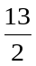O₂(g) 4CO₂(g) + 5H₂O(l)  ΔH_{c}  ΔH₁  ΔH₂  4C(s) + 5H₂(g) + 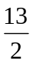O₂(g)
 |  |  |  |  | (ii) |  | Chemical companies manufacture containers filled with liquid butane for use by campers. A camper found a left-over container of butane and estimated that there was about 10 g of liquid butane left.  Using your answer in (a)(i), calculate the mass of water, at an initial temperature of 25ºC, that could be brought to the boiling point by burning this butane.  Assume that the specific heat capacity of water is 4.18 J g⁻¹K⁻¹.
 |  |  |  |  |  |  | [3]
 |  |  | (b) |  | Propanoic acid can be synthesized from butane by a 3-step reaction sequence shown below.  step 1 hot ethanolic KOH step 3  butane D E propanoic acid
 |  |  |  |  | (i) |  | Suggest the reagents and conditions used for steps 1 and 3 in this synthesis and give the structural formulae of compounds D and E.
 |  |  |  |  |  |  | step 1: ........................................................................................................................
 |  |  |  |  |  |  | step 3: ........................................................................................................................
 |  |  |  |  | (ii) |  | Name the type of reaction for step 1.
 |  |  |  |  |  |  | ...........................................................................................................................................
 |  |  |  |  |  |  | [5]
 |  |  | (c) |  | Butenedioic acid has the structural formula HO₂CHC=CHCO₂H.
 |  |  |  |  | (i) |  | Explain why butenedioic acid exhibits geometric isomerism.
 |  |  |  |  |  |  | ...........................................................................................................................................
 |  |  |  |  |  |  | ...........................................................................................................................................
 |  |  |  |  |  |  | ...........................................................................................................................................
 |  |  |  |  | (ii) |  | Draw the structural formulae of the geometric isomers of butenedioic acid.
 |  |  |  |  | (iii) |  | Butane is the feedstock for DuPont's catalytic process for the preparation of maleic anhydride which can then be converted into cis-butenedioic acid.  Explain why trans-butenedioic acid has a higher boiling point than cis-butenedioic acid.
 |  |  |  |  |  |  | ...........................................................................................................................................
 |  |  |  |  |  |  | ...........................................................................................................................................
 |  |  |  |  |  |  | ...........................................................................................................................................
 |  |  |  |  |  |  | ...........................................................................................................................................
 |  |  |  |  |  |  | ...........................................................................................................................................
 |  |  |  |  |  |  | [4]
 |  |  |  |  |  |  | [Total: 12]
 | 4 |  | Consider the following reaction scheme involving CH₂=C(CH₃)CHO:  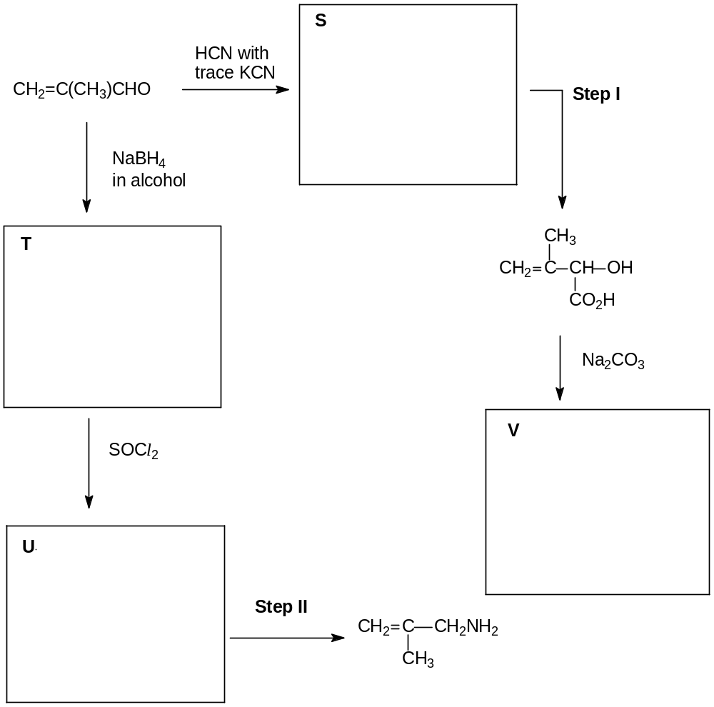  PBr₃
 |  |  | (a) |  | Draw the structural formulae for organic compounds S, T, U and V in the boxes above.
 |  |  |  |  |  |  | [4]
 |  |  | (b) |  | Suggest reagents and conditions for steps I and II.
 |  |  |  |  | step I ......................................................................................................................................
 |  |  |  |  | step II ......................................................................................................................................
 |  |  |  |  |  |  | [2]
 |  |  | (c) |  | Describe a simple chemical test to distinguish CH₂=C(CH₃)CHO and compound W which has the following structure:  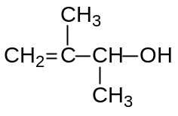  Write a balanced equation for the reaction involved.
 |  |  |  |  | ..................................................................................................................................................
 |  |  |  |  | ..................................................................................................................................................
 |  |  |  |  | ..................................................................................................................................................
 |  |  |  |  | ..................................................................................................................................................
 |  |  |  |  |  |  | [3]
 |  |  |  |  | [Total: 9]

Section B

Answer two of the three questions in this section on separate paper

5 | (a) | At a crime scene, preliminary investigations led the homicide detectives to believe that concentrated sulfuric acid was used to hurt the victim.  Some samples of blood and fibres were also collected from the victim and sent to the forensic laboratory. Upon analysis, the fibres were found to contain oxides of Q and R.  Q and R are elements in period 3 of the Periodic Table and the following are known for their oxides:  ● Oxide of Q has a melting point of 1275ºC and it dissolves readily in water. It is a good conductor of electricity in molten state.  ● Oxide of R has a melting point of 1830ºC and it does not dissolve in water. It is a non-conductor of electricity.
 |  | (i) | Identify the two oxides.
 |  | (ii) | Write an equation, with state symbols, for the reaction of oxide of Q with water. Give the approximate pH of the resulting solution formed. What is the effect of adding universal indicator to the solution?
 |  | (iii) | Relate the melting points of the two oxides to their structures and bonding.
 |  | (iv) | State and explain the variation in the maximum oxidation number of the elements sodium to sulfur in their oxides.
Concentrated sulfuric acid is commonly used in esterification reactions:

CH₃CH₂CH₂OH(l) + CH₃CO₂H(l) CH₃CO₂CH₂CH₂CH₃(l) + H₂O(l) ∆H

 |  | (v) | Draw and name the shape of sulfuric acid molecule with respect to sulfur atom, stating its bond angle.
 |  | (vi) | A student intern at the forensic laboratory made the following claim: For the esterification reaction above, the enthalpy change, ∆H, is known as the enthalpy change of neutralisation. However, ∆H cannot be calculated by using only the bond energies in the Data Booklet.  Comment on the intern’s claim.
 |  | (viii) | Suggest how propan-1-ol can be formed from 3-chloropropanal in 2 steps. Draw the structure of the intermediate that is formed. | [16]

 | (b) | The melting points of gallium oxide, Ga₂O₃, and arsenic pentoxide, As₂O₅, are 1795ºC and 315ºC respectively. By considering the likely structure and bonding of each of these oxides, write balanced equations for the reactions, if any, of each of these oxides with  - NaOH(aq)  - HCl(aq) | [4]
 |  | [Total: 20]

6 | Chlorine was first prepared in pure form by the Swedish chemist Carl Wilhelm Scheele in 1774. Being a very reactive element, chlorine is always found in compounds. It can be found dissolved in seas, salty lakes and in the ground as rock salts or halite. This question is about chlorine-containing compounds which are widely used in industrial, agricultural and medical fields.
 | (a) | Describe and explain the reactions, if any, of the chlorides of the elements sodium, aluminium and phosphorus with water, relating these reactions to the bonding of the chlorides. Give the approximate pH of any solutions formed and write equations where appropriate. |  | [6]
 | (b) | 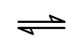  Under equilibrium conditions, 98 cm³ of Cl₂ gas dissolves in 100 cm³ of water at room temperature and pressure. The equilibrium set up is as follows:  Cl₂(aq) + H₂O(l) Cl⁻(aq) + HClO(aq) + H⁺(aq)
 |  | (i) | Calculate the equilibrium concentration of Cl₂ in mol dm⁻³.
 |  | (ii) | Write an expression for the equilibrium constant, K_{c}, of this reaction.
 |  | (iii) | Given that the numerical value of the equilibrium constant for this reaction is 4.7 x 10⁻⁴ and using your answer in (b)(i), calculate the equilibrium concentration of H⁺(aq) and hence pH of the solution.
 |  | (iv) | Predict and explain the change in pH (if any) when aqueous silver nitrate is added to the above solution. | [6]
 | (c) | Compound C, C₅H₁₀Cl₂, reacts with hot aqueous potassium hydroxide to produce compound D. Oxidation of D gives compound E which does not react with Tollens’ reagent. 1 mole of compound E reacts with 2 moles of 2,4-dinitrophenylhydrazine to give an orange precipitate. Both D and E react with hot alkaline aqueous iodine to give a yellow precipitate.  When C reacts with hot ethanolic KOH, a different compound F is formed. F reacts with hot acidified potassium manganate (VII) to give HO₂C-CH₂-CO₂H and 2 moles of CO₂ as products.  Identify and draw the structural formulae of compounds C, D, E, F and explain the reactions described. |  | [8]
 |  | [Total: 20]

7 | This question is on acids and bases.
 | Ethanoic acid, CH₃COOH is a weak acid which is responsible for the sour taste and pungent smell of vinegar.
 | (a) | Write the equation for the dissociation of CH₃COOH in water. |  | [1]
 | (b) | It is found that the pH of CH₃COOH is 2.88. Determine the percentage of 0.01 mol dm⁻³ of CH₃COOH that has dissociated in water. |  | [2]
 | (c) | In an experiment, 20 cm³ of 0.01 mol dm⁻³ aqueous ethanoic acid was added to 10 cm³ of 0.01 mol dm⁻³ sodium hydroxide.
 |  | (i) | Write a balanced equation for the above reaction.
 |  | (ii) | Explain, with the aid of two equations, how the solution formed in the experiment can control pH upon addition of small amounts of H⁺ and OH⁻. | [4]
 | (d) | A bromoalkane, 2-bromo-2-methylpropane, (CH₃)₃CBr is hydrolysed by excess aqueous sodium hydroxide.
 |  | (i) | Write a balanced equation for the reaction.
The following results were obtained from an experiment on the above hydrolysis.

time/min | [(CH₃)₃CBr]/mol dm⁻³
0 | 0.200
25 | 0.152
50 | 0.115
75 | 0.088
100 | 0.067
125 | 0.051

 |  | (ii) | Plot the data on suitable axes and use your graph to deduce the order of the reaction with respect to (CH₃)₃CBr.
 |  | (iii) | Given that the same graph was obtained when the experiment was repeated with the concentration of aqueous sodium hydroxide being doubled, deduce the order of reaction with respect to sodium hydroxide.  Hence construct a rate equation for the reaction.
 |  | (iv) | State how the half-life of the reaction is affected when the experiment is repeated with the concentration of (CH₃)₃CBr doubled.
 |  | (v) | In another experiment conducted using aqueous NaOH, (CH₃)₃CCl was used instead of (CH₃)₃CBr. With the aid of the Data Booklet, state how you would expect the rate of this reaction to compare to that of the reaction of (CH₃)₃CBr with aqueous NaOH. Explain your answer.
 |  | (vi) | Suggest how 2-bromo-2-methylpropane can be synthesised from 2-methylpropan-1-ol, CH₃CH(CH₃)CH₂OH. | [13]
 |  |  | [Total: 20]

